Report on planning tools suitable for the implementation of a Pilot Project in the City area of Brest in Belarus

- Background
On 16th October 2013 a round table took place in Minsk within the premises of the City Planning Institute .
The goal of the meeting was:
- Overview of energy efficient incorporated in the practice of the urban planning
- UN-Habitat plans and perspective to support Belarus cities for sustainable urban development
- Determine ESIB pilot project expected results
- To find out reputable tools and methodology to be used for assessing energy efficiency in urban planning and residentialdevelopment units.
During the roundtable emerged substantially twoplanning tools and methodologiessuitable for instance to conduct a sensitive analysis namely, the LEED NB /NC and OPEN HOUSE.
Mr. Lorenzo Carapellese, ESIB-INNOGATE urban planner expert was asked to better define and suggest the tool and methodology applicable for the implementation of some pilot projects in the City of Brest in an area of 109 hectares the way to boost energy efficient urban planning in Belarus.
Here by a very synthetic description of the main methodology suitable for sustainable urban planning and building design for environment and energy savings & efficiency.

- Methodology and Tools for sustainable urban planning and building design for energy saving and efficiency.
In 2008 under the umbrella of the Zofnass Program Foundationthe Harvard University was appointed to develop guidelines and metrics to promote, design and implement sustainable large infrastructure.
After two years with the collaboration of CEEQUAL, FIDIC, ASCE FUNDATION and Federal Agencies were inventoried more than 900 rating system and/or methodology tools, 120 was better identified.
After identifying the majority of the existing rating systems, a select 6 were finally completely assessed representing the more familiar and today widely used systems. The list of course continue to grow.
The analysis of each of the chosen sustainability rating systems consisted of first reviewing each of the system’s requirements related to infrastructure throughout four main categories of impact:
- The Natural World,
- Quality of Life,
- Climate and
- Resources.
The corresponding metric for each of these requirements were also identified.

- Rating system analysis

Each requirement within the rating system also identified the type of infrastructure pertinent to each point. Categories of infrastructure were assigned a reference number that appears in the matrices as follows:

3.1 Infrastructure Types:

1. Transportation (Systems, Facilities + Components)
Vehicular Systems
Air Transport Systems
Rail Transport
Ports and Waterways
Other
2. Energy
Electrical Power
Gas
Solar
Other
3. Water (Supply Systems + Components)
4. Waste (Control Systems + Components)
5. Telecommunications (Systems + Components)
Data Centers
6. Land Use
FAR
Site Coverage
Other
7. Other (Infrastructure

3.2 The more reputable planning tools selected were:

1.CASBEE for Urban Development
Description
CASBEE (Comprehensive Assessment System for Building Environmental Efficiency) is a method for evaluating and rating the environmental performance of buildings. It is a comprehensive assessment of the quality of a building, covering aspects such as interior comfort and consideration for scenery, as well as evaluating environmental consideration in the form of using materials and equipment that save energy or cause smaller environmental loads.
CASBEE Assessments are ranked in five grades: Excellent (S), Very Good (A), Good (B+), Fairly Poor (B-) and Poor (C).

2.LEED for Neighborhood Development
Description
LEED for Neighborhood Development (LEED-ND) is a point-based rating system for design and construction on the neighborhood scale. Points are offered in the following categories: “Smart Location & Linkage,” Neighborhood Pattern & Design,” and “Green Construction & Technology.”
Year: 2007 Currentlyoperative.
Where: U.S. Eventually, it may be used internationally.
Who: U.S. Green Building Council, Congress for New Urbanism, Natural Resources
Defense Council
Ratings: certified, silver, gold, platinum
Assessments: Smart Location and Linkage, Neighborhood Pattern & Design, Green
Construction and Technology
What: Projects, usually of an urban design / multi-building scale, usually developed by one party.

3.CASCADIA: The Living Building Challenge
Description
Cascadia’s mission is to promote the design, construction and operation of buildings in Oregon, Washington and British Columbia that are environmentally responsible, profitable and healthy places to live, work and learn.
Year:1999
Where: Pacific Northwest, mainly Oregon, Washington, British Columbia.
Why: A Bio-regional approach to problem solving and market transformation. It is aimed at acting as a catalyst for organizations both in the private and public sector through creative programs, events and tools
Who: Cascadia Region Green Building Council.
Ratings:No credits, just pre-requisites, so only one certification.
Assessment: Implicit vs. Explicit. For example, there is one energy pre-requisite:
netzero energy. The Net Zero Energy goal has been made explicit, but implicit in the
requirement are dozens of strategies that should be done in order to make the building as efficient as possible prior to using renewable energy.
What: Living Building Challenge, Living Sites Tool, Living Communities Tool.
Note: The LB Challenge takes a top-down rather than bottom up approach, starting not with how to be less bad, but rather attempting to define the ideal or ultimate target and making that the only level of compliance.

4.Green Globes
Description
Green Globes is both a guide for integrating green design principles and an assessmentprotocol. Using confidential questionnaires for each stage of project delivery, the program generates comprehensive on-line assessment and guidance reports. Using Green Globes helps to design a building that will be energy and resource efficient, will achieve operational savings and be healthier to work or live in. Green Globes supports an integrated design approach to project delivery. Because ninety percent of design decisions are typically made during the first ten percent of the design process, using an integrated approach can help ensure that sustainability goals are established before design decisions have been made and that these are monitored throughout each stage of the project.
This helps to avoid unclear goals, disjointed efforts and miscommunications between team members. Many design teams often jump on the "green" bandwagon late in the design process after the majority of envelope, systems and site development choices have already been made.
Making meaningful changes this late in the process is costly and in some cases impossible.
Experience has shown that using integrated design produces cost economies and achieves a greater degree of sustainability compared to the conventional design process.

5.BREEAM: Building Research Establishment's Environmental

Assessment Method
Description
(Building Research Establishment’s Environmental Assessment Method)
http://www.breeam.org/
Year: 1990
Where: Based in the UK but can be used internationally.
Why: The BREEAM family of assessment methods and tools are all designed to help
construction professionals understand and mitigate the environmental impacts of the developments they design and build.
Who: Building Research Establishment Ltd
Ratings: pass, good, very good, excellent and outstanding.
Assessment: Management, Health and Wellbeing, Energy, Transport, Water, Material and Waste, Land Use and Ecology, Pollution
What: BREEAM Tools: Life Cycle Analysis (LCA) Environmental Profiles, Green Guide to Specification, Envest whole building LCA Software BREAM Bespoke, Courts, Sustainable Homes, Ecohomes, Healthcare, Industrial, International, Multi -Residential, Prisons, Offices, Retail, Education, Communities
Note: According to its website BREEAM isthe world's most widely used environmental assessment method for buildings.

6.CEEQUAL
Description
The Civil Engineering Environmental Quality Assessment and Award Scheme
http://www.ceequal.com/
Year: 2003
Where: UK
Why: To encourage environmental excellence in civil engineering projects and deliver improved environmental and sustainable performance in project specification, design and construction.7
Who: CEEQUAL was developed by an industry-representative team led by the ICE, with government financial support from the DETR (now Defra) and DTI Partners in Innovation (PII) schemes, and from the ICE's Research & Development Enabling Fund, UK.
Ratings: Whole Project Award, Client and Design Award, Design Award, Construction
Award, Design and Build Award. The awards range from pass, good, very good and
excellent, as compared to the legal minimum effort.
Assessment: In the assessment process, the questions not relevant to the specific project are scoped out in consultation between the Assessor and the CEEQUAL-appointed Verifier. When the Assessor has completed the assessment, the completed Spreadsheet is sent to the Verifier for review and preparation for the verification meeting, which normally takes place on site. After the decision is taken, the final score and Award recommendation is checked and ratified by CEEQUAL Ltd.
What: Civil engineering or public realm projects, such as roads and railways, airports, coast and river works, water supply and wastewater treatment, power stations, retail and business parks.
Note: A ’Term Contracts’ version to accompany the Scheme Description and Assessment Process Handbook is currently being developed. Its intention is to recognize environmental performance post-construction, over a number of years.

- Comparison of Analyzed Rating Systems

The matrix format utilized for six of the above described rating systems enabled the research team to compare the systems directly and what niches they filled. The following diagrams illustrate key aspects of their structure and objectives:

- Complexity and Rigor of the documentation needed

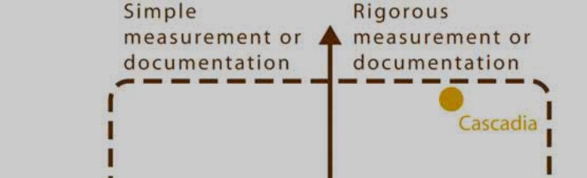
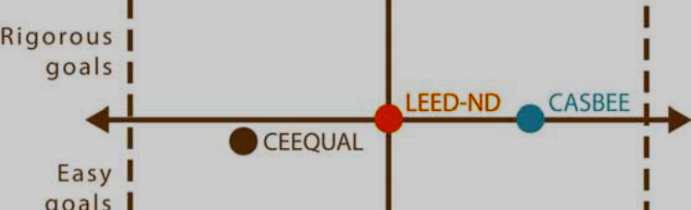
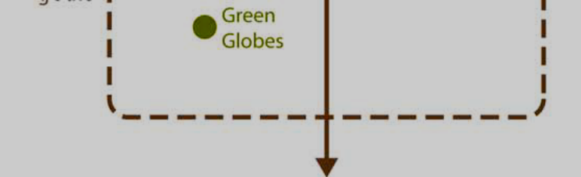

- Rating system documentation

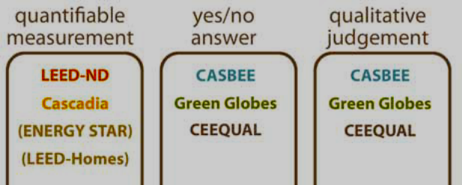
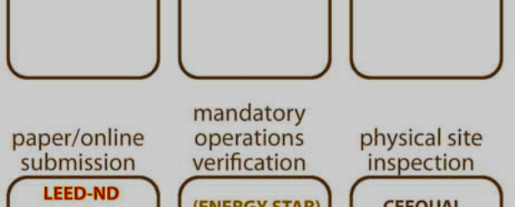
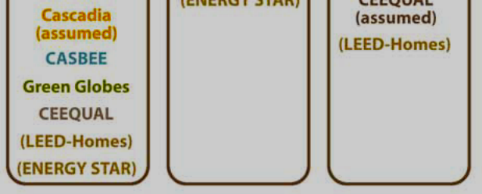

- Primary Structure and Relevant Issues

- Zonfass Rating system

The analyses carried out on of the existing rating systems’ provided a rich source of material, perspective and context and served as a base point of departure for developing of a further New Rating Methodology that is theEnvision -Zofnass Sustainable Infrastructure Rating System. The methodology designed in 2008, now at is Second Version ( 2012) aim to support the built space, enhance the people’slive and the infrastructure impact on the environment, is based on four categories such as Resource Allocation,Natural World, Climate Change, and Quality of Life.

The declared goals of the method are:
- to encourage higher sustainability performance for all civil engineering infrastructure – not only technical performance but also from a social, environmental, economic perspective (the triple bottom line)
- promote higher performing solutions that take into account lifecycle considerations, working more closely with communities, and emphasizing restorative approaches.
There system is organized in four stage:

1 — Self-assessment checklist.
2 — Third-party, objective rating verification.Public recognition.
3 — Tool for complex or multi-stage projects. Available from 2012
4 — Optimization support tool.Available from 2012.

And the process/ decision making model is structured in the following steps:

5.1. ZOFNASS Modelling

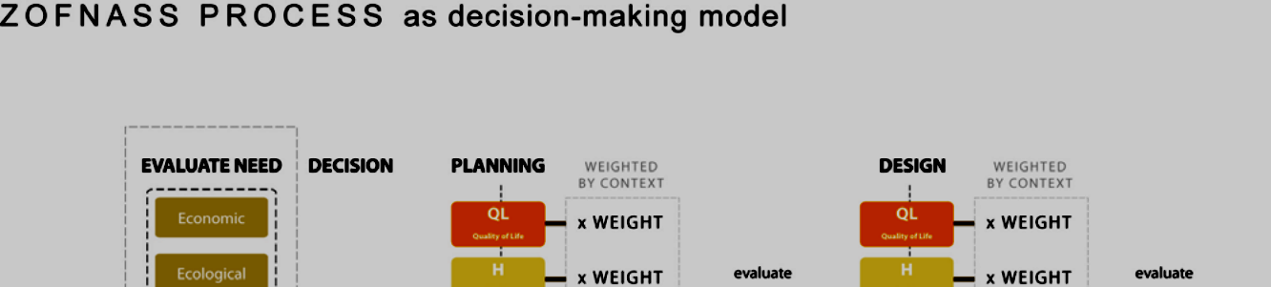
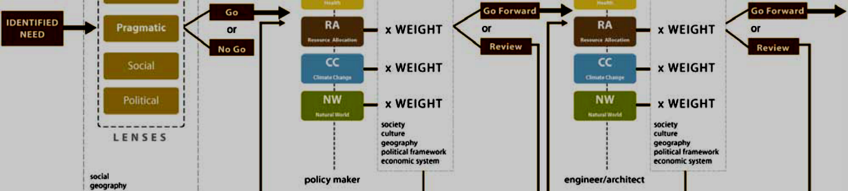
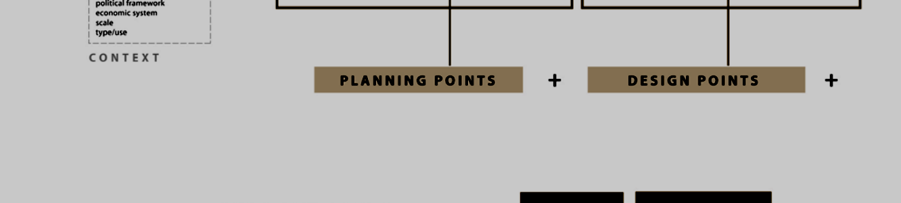
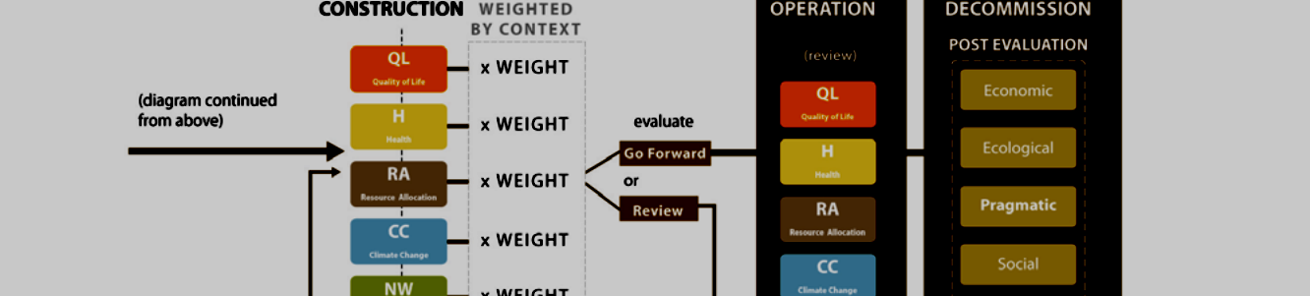


6. Open House, the European open sustainability evaluation method

During the analysis period carried out by the University of Harvard for the ZOFNASS Foundation a quite similar project was approved and financed by the EU under the 7 PFA, theEnv. 2009.3.1.5.2 named Open House aimed to “ Benchmark and labeling the sustainability performance of Building”. The project started in 2010 with a project duration of 3,5 years. The project ended in February 2013 and was presented in July the last.
The project was promoted by an European consortium and tested during the time in 67 studies over 35 Eu countries inside and outside the Open House consortium.

Also the Open House consortium carried an investigation over the most popular and
accredited methodology on sustainable urban planning and building assessment throughout a questionnaire.

The assessment of the different methods utilized the following elements and criteria:

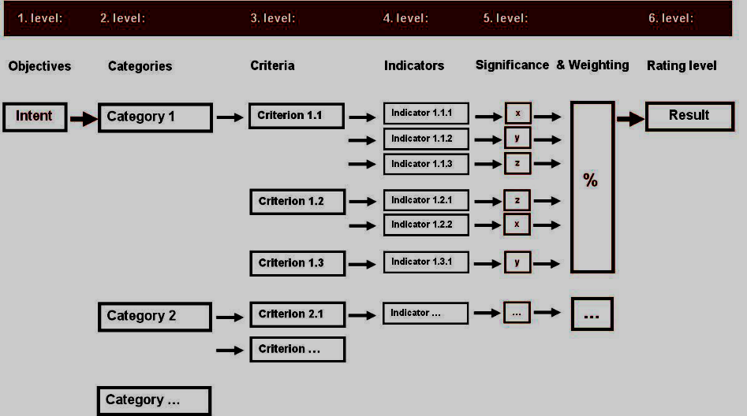

Comparison of the main assessment methods.

BREEAM |  | LEED |  | DGNB |  | HQE
Assessment method | BRE Environmental Method |  | Leadership in Energy and Environmental Design |  | DGNB Certificate |  | Démarche HQE
Certification body | BRE |  | USGBC (United States Green Building Council) |  | DGNB (Deutsche GesellschaftfürNachhaltigesBauen - German Sustainable Building Council) |  | CertivéA (for non-residential buildings)
Launch | 1990 |  | 1998 |  | 2007 |  | 1996
Internationalisation | BREEAM International  BREEAM Europe  BREEAM Gulf  BREEAM Netherlands  BREEAM Spain |  | LEED Brazil  LEED Canada  LEED Emirates  LEED India  LEED Italy  LEED Mexico |  | Cooperations:  ÖGNI (Austria)  BGBC (Bulgaria)  DGBC (China)  DGNBH (Hungary)  SGNI (Switzerland)  Thailand Council of Sust. Construction (Thailand) |  | -
Updates | according to demand |  | up until now, according to demand; three-year rhythm is planned |  | according to demand |  | according to demand
Certification by third party | BRE |  | GBCI (Green Building Certification Institute) |  | DGNB (Deutsche GesellschaftfürNachhaltigesBauen - German Sustainable Building Council) |  | CertivéA Assessor
Auditor | registered and independent BREEAM Assessortraining with examination |  | certification performed by GBCI registered and independent "LEED Accredited Professional"(LEED AP) can support the implementation of the requirements in a project, however, their appointment is not mandatory examination: formal training is not required |  | registered and independent DGNB Auditor  training and examination |  | accredited by CertivéA  intern training
Rating process | • design phase: pre-certificate (Interim BREEAM Certificate)  • commissioning: certificate (Final BREEAM Certificate) (on completion) |  | LEED-NC, -CS, -CI: Assessment of the relevant criteria after the design phase and the commissioning;  certificate on completion;pre-certificate is possible in the case of LEED-CS |  | • design phase: pre-certificate  • commissioning: certificate (following completion) |  | • design phase: pre-certificate for programmation and conception  • commissioning: certificate (following completion)
Rating levels | pass (≥ 30 %)  good (≥ 45 %)  very good (≥ 55 %)  excellent (≥ 70 %)  outstanding (≥ 85 %) |  | certified (≥ 40 points)  silver (≥ 50 points)  gold (≥ 60 points)  platinum (≥ 80 points) |  | bronze (≥ 50 %)  silver (≥ 65 %)  gold (≥ 80 %) |  | No aggregation of categorys‘ score achieved into one rating level
Minimum standards and obligatory criteria | minimum standards, determination acc. to rating levels |  | predefined minimum criteria (prerequisites) in all categories |  | observance of predefined fulfilment degree in each category dependent on the rating level |  | observance of predefined fulfilment degree in each category dependent on the rating level
Weighting | weighting of the individual categories |  | no weighting; set number of points for criteria |  | weighting of the individual categories, furthermore use of significance factors for criteria |  | No weigthing of categories. Each is equally weighted to give a profile score.

6.1 Open House- full system assessment tool
The OPEN HOUSE full system includes a list of 56 indicators that have been determined in the outcomes by comparing existing international and European assessment methodologies and systems and analysing existing standards concerning the sustainable built environment.
Here by a synthesis of the Open House full system method.

Category |  | Nr. |  | Indicator
Environmental quality |  | 1.1 |  | Global warming potential
 |  | 1.2 |  | Ozone depletion potential
 |  | 1.3 |  | Acifidication potential
 |  | 1.4 |  | EutrophicationPotential (EP)
 |  | 1.5 |  | Photochemical Ozone Creation Potential
 |  | 1.6 |  | Risks from materials
 |  | 1.7 |  | Biodiversity and Depletion of Habitats
 |  | 1.8 |  | Light Pollution
 |  | 1.9 |  | Non-Renewable Primary Energy Demand
 |  |  | 1.10 |  | Total Primary Energy Demand and Percentage of Renewable Primary Energy
 |  |  | 1.11 |  | Water and Waste Water
 |  |  | 1.12 |  | Land use
 |  |  | 1.13 |  | Waste
 |  |  | 1.14 |  | Energy efficiency of building equipment (lifts, escalators etc.)

Category | Nr. | Indicator
Social Functional Quality | 2.1 | Barrier-free Accessibility
Social Functional Quality | 2.2 | Personal Safety and Security of Users
Social Functional Quality | 2.3 | Thermal Comfort
Social Functional Quality | 2.4 | Indoor Air Quality
Social Functional Quality | 2.5 | Water Quality
Social Functional Quality | 2.6 | Acoustic Comfort
Social Functional Quality | 2.7 | Visual Comfort
Social Functional Quality | 2.8 | Operation Comfort
Social Functional Quality | 2.9 | Service Quality
Social Functional Quality | 2.10 | Electro Magnetic Pollution
Social Functional Quality | 2.11 | Public Accessibility
Social Functional Quality | 2.12 | Noise from Building and Site
Social Functional Quality | 2.13 | Quality of the Design and Urban Development of the building and Site
Social Functional Quality | 2.14 | Area Efficiency
Social Functional Quality | 2.15 | Conversion Feasibility
Social Functional Quality | 2.16 | Bicycle Comfort
Social Functional Quality | 2.17 | Responsible Material Sourcing
Social Functional Quality | 2.18 | Local Material

Category | Nr. | Indicator
Economic Quality | 3.1 | Building related Life Cycle Cost
Economic Quality | 3.2 | Value Stability

Category | Nr. | Indicator
Technical Characteristics | 4.1 | Fire Protection
Technical Characteristics | 4.2 | Durability of the structure and Robustness
Technical Characteristics | 4.3 | Cleaning and maintenance
Technical Characteristics | 4.4 | Resistance against hail, storm high water and earthquake
Technical Characteristics | 4.5 | Noise Protection
Technical Characteristics | 4.6 | Quality of the building shell
Technical Characteristics | 4.7 | Ease of Deconstruction, Recycling, and Dismantling

Category | Nr. | Indicator
Process Quality | 5.1 | Quality of the Project’s Preparation
Process Quality | 5.2 | Integrated Planning
Process Quality | 5.3 | Optimization and Complexity of the Approach to Planning
Process Quality | 5.4 | Evidence of Sustainability during Bid Invitation and Awarding
Process Quality | 5.5 | Construction Site impact/ Construction Process
Process Quality | 5.6 | Quality of the Executing Contractors/Pre-Qualification
Process Quality | 5.7 | Quality Assurance of Construction Execution
 | 5.8 | Commissioning
 | 5.9 | Monitoring, Use and Operation

Category | Nr. | Indicator
Process Quality | 6.1 | Risks at the Site
Process Quality | 6.2 | Circumstances at the Site
Process Quality | 6.3 | Options for Transportation
Process Quality | 6.4 | Image and Condition of the Location and Neighbourhood
Process Quality | 6.5 | Vicinity to amenities
Process Quality | 6.6 | Adjacent Media, Infrastructure, Development

Totally six are the categories taken into consideration. Each category is composed of several indicators assessing different key issues for the sustainability performance of the project.
Each indicator consists in one or several sub-indicators that evaluate a precise issue covered by the indicator topic.
6.2 Assessement Tools
The following tools are provided to help the assessors to perform the building assessment:

- Common Workshop presentation
- Assessment forms
- Annexes templates
- Indicator tools
- Scoring card
- LCA tool
- Online assessment portal(from May 2012).
At the time of the final presentation in July 2013 the Open House system was fully complete and operational to assess Building for Offices premises being considered those buildingsmore complex than residential areas.
6.3 Final Remarks
In the incoming years it’s supposed the Open House will be implemented in all Europe 27 countries for the more important types of infrastructure as the unique European open and free methods of benchmarking and labeling tools of the sustainability performance of the buildings.
Moreover the use of Open House can profit of others European tools, (like ESPON, Superbuilding …)and when is necessary, also be integrated with the others national and international evaluation systems of sustainability ( Leed, BREEAM…).
These are the reason why the Open House Assessment Guideline,as the main assessment document developed by all European partners in a transparent and open process, can be the basis for further application for the implementation of the Pilot Project also in the Republic of Belarus especially in Brest that lays on the border of the country with Poland ( partner of the Project).
The Open House steps and procedures can be also useful for the preparation and submission to IFI’s for credit facilities being the method fully recognized by the main financial institution.
As for the six category of the Open House assessment it is recommended to try to use all of them from the beginning of the project process, the way to verify if all the 56 parameters required are available, and in how many time. That means entail the need of dedicated and integrated professional has to be appointed on time and be on board prior to start the assessment. It must be take into consideration also that for some of the category and subcategory of investigation ( i.e.Site Location…) the Open House clearly refer also to other methods, such LEED ND or BREEAM etc. Thus giving the possibility to the professional team appointed to the project to get indirectly acquainted with other widespread and consistent methodologies.
The possibility to submit questions on line to OPEN HOUSE experts must be considered an advantage, as well the opportunity to get some training on the methodology during the entire process ( learning by doing).

7.Bibliography
i) The comparison between the six methods (CASBEE, LEED NB,CASCADIA, GREEN GLOBE, BREEAM and CEEQUAL was taken from the document:”Zofnass Program for Infrastructure Sustainability -Summary and Analysis of Existing Sustainability Rating Systems” by Richard Jennings,Shelby Doyle, Mary Gourlay,Ann Shi, LeetaMohanty, Holly Wasilowski;
ii)CASBEE for Urban Development – Technical Manual 2007 Edition
iii) CASBEE for new construction 1 and 1B 2010 and 2008 Edition
iv) LEED – Designing Low Carbon Neighborhoods with LEED ND- October 2009 Edition
v) LEED 2009 for Neighborhood development
vi) BREEAM Communities Technical Manual 2012
vii) BREEAM International New Construction Technical Manual
viii) CEEQUAL for UK and Ireland Project Assessment Manual
ix)CEEQUAL – Sustainability assessment and awards for Civil Engineering, Infrastructure,landscaping and public realm 2012
x) Gree Globe Guiding principles. Compliance, assessment& user instruction 2012
xi) Green Globe- Weighted criteria and flexibility features 2012
xii) A handbook for planning and conducting charettes for high performance building
xiii) CASCADIA – Living building challenge user guide 2007
xiv) Envision Zonfass Manual
xv) Zonfass rating system
xvi) Open House Assessment Package 2013

