

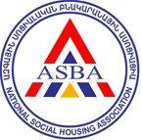



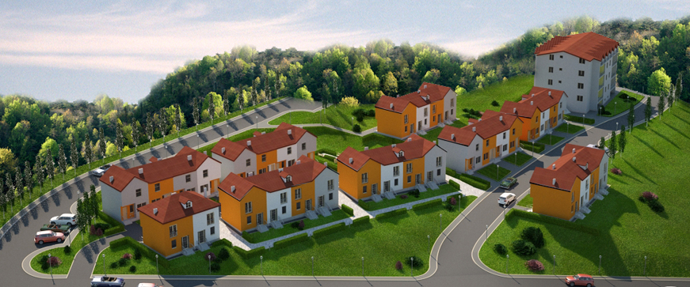

Project Highlights
Within a cooperation framework with the Armenian National Social Housing Foundation (ASBA), ESIB Project interfered in design of social housing premises for construction in city of Dilijan in Armenia. «Dilijan Housing Complex» is a social affordable housing complex aimed to offer affordable dwellings to low and middle income families of Dilijan, in partnership with Dilijan municipality. ASBA partnered with ESIB for seeking possibilities to integrated modern energy efficiency solutions into the development and construction, which allowed cutting the energy content of the future social houses by almost half, while reducing construction costs. Considering the social orientation of this housing, the affordability of heating bills and apartment cost are of major importance for the future dwellers.
Key Results
- Energy Savings 220,361 kWh/year
- Cost Savings (residents) EUR 13,753/year
- Increased Social Housing Space 13%
    - Heat demand 80kWh/1m²
(reduced from 180 kWh/1m²)

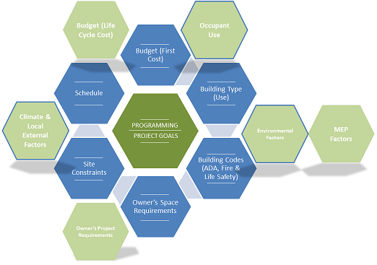
The initial buildings were aligned to the landscape without consideration of utilization of solar energy (living rooms were mostly oriented towards North, while bedrooms – towards South), no insulation was intended, the building had multiple architectural solutions which had aesthetic purpose, yet would result in major heat losses and thermal bridges. The selected construction elements would have been cost- and labor-intensive to insulate. In addition, the buildings construction was planned in heavy monolith concrete which (i) cost (including foundations) is much higher than frame structure filled with light weight concrete or perlite blocks, (ii) poor performance against the seismic rules, (ii) with a high energy content of materials, and (iv) high recycling costs, in addition to the high heat bill. The roofs were also intended of zigzag-shaped monolith concrete – a heavy and vulnerable element from drainage perspective.

Project Approach
ESIB Project signed a Memorandum of Understanding with Armenian National Social Housing Foundation (ASBA) in June 2012 to facilitate the development of mutually beneficial cooperation in the fields of residential building energy efficiency, in the common interest of the Parties and for the energy efficiency project implementation in city of Dilijan in Armenia through the integration of energy efficiency measures into the development and construction of new housing, while striving for cost-minimization and reduced operational cost. ESIB team has worked with ASBA and their architectural design contractors on a round of revisions of the initial design with the application of integrated building design principles which are currently used worldwide for the development of high performance buildings. Some of the noteworthy results of the added energy efficiency solutions in the building design included a substantial Increase in useful area of the planned housing, reduction of façade areas, building shape coefficient, reduced construction cost. The integration of proposed measures would also result in reduced heat losses and heat demand, and associated future heating bills, while bringing to reduced construction costs.

The ESIB team reviewed ASBA’s general construction plans, architectural sketches, indoor layout and construction detail, provided recommendations with regards to compliance with energy codes, utilization of passive solar energy, integration of cost-effective energy efficiency solutions in building design and construction. The ASBA and ESIB technical teams worked closely on several versions of the designs in iterations.

ESIB project provided recommendations with regards to all design elements, including the following:

- General planning: ESIB recommended to change orientation of future residential cottages’ living-rooms towards South, and expand windows on the Southern side, while reducing window areas on the Northern sides to optimize penetration of light and solar energy, while minimizing the heat losses on the Northern side. Similarly, it was recommended to cluster the cottages into larger groups which would reduce the external façade areas, as well as replace multiple small windows with single larger windows to minimize the heat losses from joints.
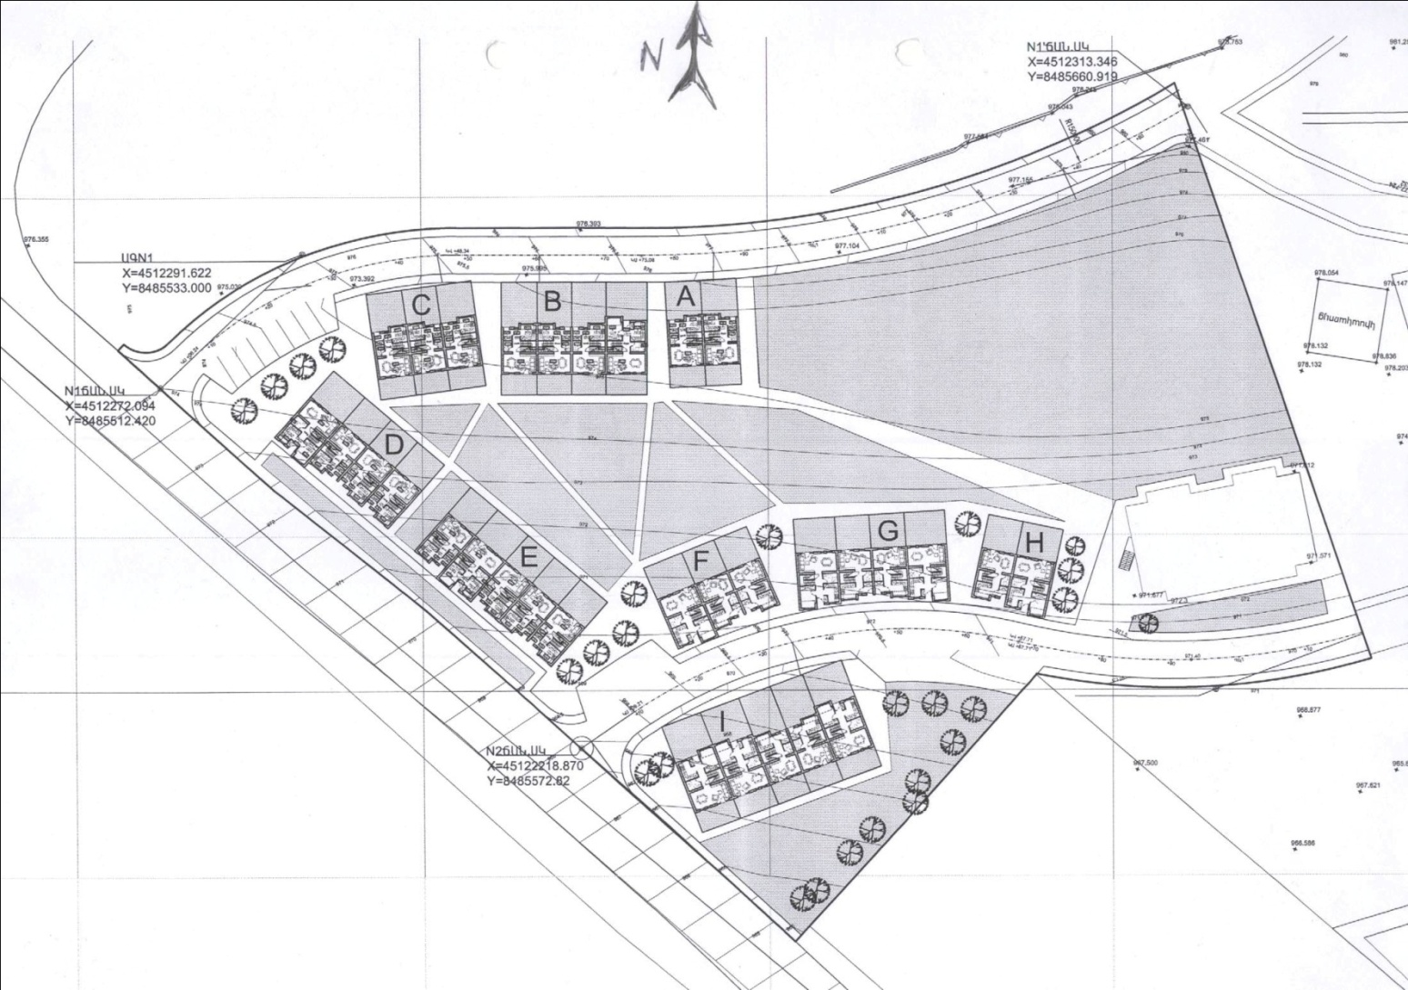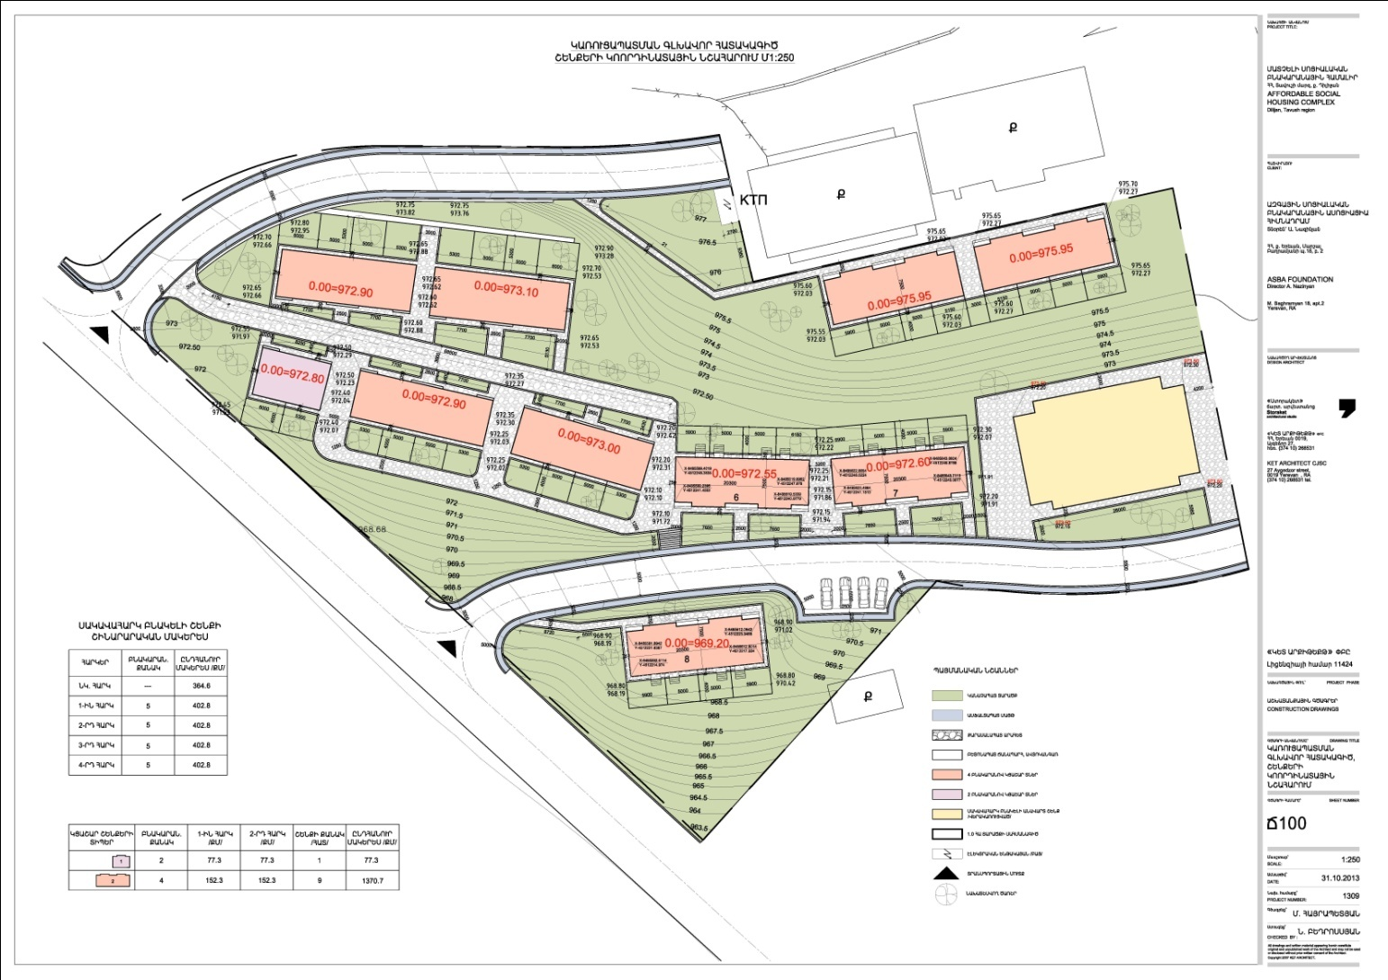
General plan of Social Housing village before (left) and after (right) optimized solar orientation

- Roof shape: The initial design foresaw individual gable roofs dropping the front-part zigzag, made of concrete for each cottage. It was recommended to change the direction of the roof declivity, which would also reduce the surface of the external walls and would contribute to the removal of precipitation. ESIB proposed to build a light ceiling covered by a unified hip roof with embedded perlite insulation. The developer chose a compromise version of a gabled valley roof (see below pictures). For the last version it was suggested to provide the attic loft roof insulation with 16 cm rough packages of Styrofoam or at least with 35-40 cm of pumice macadam.

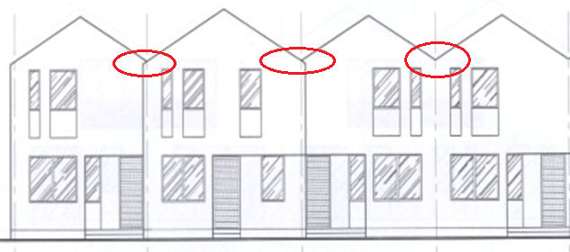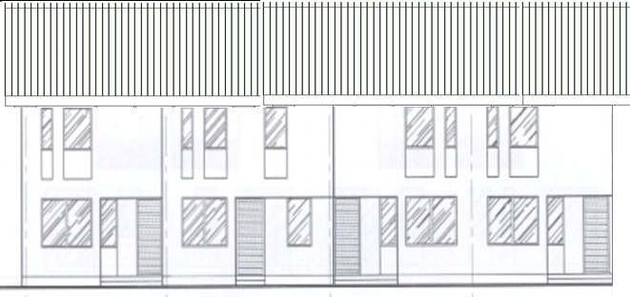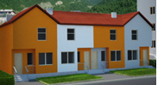
The initial ASBA design (left), ESIB proposal (middle), the compromise version (right)

- Building envelope: ESIB recommended improving the building shape coefficient through elimination of unnecessary protrusions and concaves in the façade. Some of these broken façade elements had thermal bridges which would have been extremely labor and cost-intensive to insulate. Considering that the developer was also aiming at attractive exterior of the complex, it was recommended to use multi-color façade as the most common solution in such cases. ESIB recommended that 6cm extruded polystirol insulation is used for facades, instead of the initially planned 3cm.
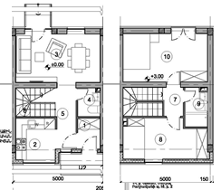
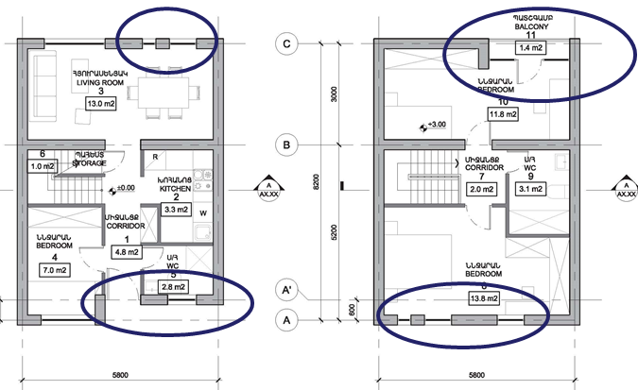
The multiple small windows, unnecessary protrusions and concave balcony (left) were eliminated on the revised design by single larger window, French window-balcony, and flatter façade (right)

- Construction detail: The two expert teams could not reach a consensus on the construction material – ASBA has chosen monolith concrete reinforced construction, while ESIB recommended a carcass building (concrete frames (beams and columns) filled with low density blocks (as perlite)). According to the ESIB experts, a carcass wall is not only less expensive, but also considerably reduces the demands on foundations and bearing structure cost, bringing more reliability and efficiency to the seismic rules applications, and increasing the natural thermal insulation, while minimizing the need for “wet works”, which extend the construction process and require more qualified workers. ASBA, as the developer, has found the monolith concrete wall more suitable for the site geology.
ASBA Financing

The Armenian Social Housing Foundation is partnering with the Dutch International Guarantee for Housing – DIGH Foundation (NL) for financing for the social housing project in Dilijan, with guarantees from DIGH loan, guaranteed by GroenWest (Dutch Housing Corporation).
Total planned investment:
1.3-1.5 Mln Euro.
Further financing is being discussed for similar projects in Hrazdan, Vedi, Ashtarak, Vanadzor and Alaverdi
Source: www.asba.am

It is noteworthy, that the above issues associated with the building design are not uncommon for the construction practices in Armenia. In almost all cases, new buildings are designed and without consideration of the Building Energy Codes (RACN II -7.02-95 Building Thermal Physics; and SNiP 23-02-2003 Thermal Protection of Buildings). Many developers, designers and even project assessors consider these norms voluntary and ignore them at their discretion. While this malpractice is further aggravated by the lack of political will from state authorities to improve the enforcement of building energy codes. Nonetheless, often the failure to integrate energy efficiency into building design is an awareness issue. Energy efficient construction materials and techniques often substantially reduce the construction costs, expand the useful space, make construction lighter and seismically robust, reducing the need for installed heating equipment and associated operation cost. Since developers may often be disconnected from the operation decisions due to the split incentives (developers are rarely responsible for paying heating bills, this is the responsibility of owners/renters), it is important for developers to understand the marketing value of energy efficient construction. Should the new buildings have an energy efficiency advantage over other properties available in the market, these can be advertised for the opportunity to save on heating bills in this estate.

It is also noteworthy, that ASBA team has only partially accepted the ESIB recommendations. Some of the justifications were considerations of architectural aesthetics, acceptability by local community, and site geological specifics. Nonetheless, the achieved compromise still allowed substantively improving the future buildings’ energy performance. ASBA further intends to disseminate building energy efficiency practices to existing buildings in Dilijan community, which was also discussed during the townhall meeting on 17 December 2013, where ESIB project team presented the results of the EE-integrated social housing project.

ESIB project also intended to conduct a final building energy audit, when construction phase was completed, but due to the delays in construction, the completion of the construction phase was postponed until after the ESIB project closure.

Results
- The design changes resulted 13% increase in cottage area, while this lead to 9% reduction in total building envelope surface
- The minimization of thermal bridges and insulation brought to 44% reduction in perspective thermal losses during the heating season, and similarly – 44% in heating bills
- The calculated heat demand per 1 m² of residential space during the heating season was 162kWh, and the energy efficiency measures allowed to reduce it to 80kWh/m², by over 50%.
- The ESIB team has recommended that the buildings are heated with natural gas, however, according to ASBA, there are certain bottlenecks for bringing the natural gas network to the project site. Hence, all heating costs are calculated for electric heating. However, should heating with natural gas become possible, the heating costs could be 47% less than the electric bills.

The below table summarizes the key performance indicators associated with building design for the initial ASBA baseline, the ESIB version of the building design and the compromise version developed based on the partial acceptance of ESIB recommendations.

Category | Measurement unit | ASBA -Baseline | ESIB Proposal | ASBA-ESIB Compromise
Number of cottages |  | 32 | 32 | 38
Cottage area | m² | 2,181 | 2,380 | 2,474
External Wall Area | m² | 3,048 | 2,400 | 5,501
Total building envelope surface | m² | 6,042 | 5,257 | 5,501
Heat losses during the heating season | m^{2o}C/W | 352,941 | 152,329 | 198,756
Funds required for heating during 1 heating season | EUR | 22,027 | 9,507 | 12,404
Heat losses during the heating season for 1 cottage | kWh | 11,029 | 4,760 | 5,230
Funds required for heating over 1 heating season for one cottage | EUR | 688 | 297 | 326
Share of building envelope area per 1m² dwelling space | kWh | 2.77 | 2.21 | 2.22
Building Shape Coefficient |  | 0.71 | 0.62 | 0.72
Heat demand per 1 m² residential space during the heating season | kWh / m² | 162 | 64 | 80
Cumulative heat demand |  | 205 | 142 | 160
In case of heating with natural gas (currently not considered by the developer due to issues with gas supply)
Heating costs during the heating season | AMD | 6,435,109 | 2,777,387 | 3,623,882
Heating costs per cottage during the heating season | AMD | 170,159 | 73,441 | 80,694
Heating cost reduction compared to electric heating in % | % | 47

Lessons Learned
- Integrating energy efficiency into construction of new buildings in design phase allows capturing the benefits offered by energy efficient materials and technical solutions at a substantially lower cost than in existing buildings.
- The incremental costs associated with added energy efficiency measures in building was offset with substantial reduction in costs due to reduced bearing structures, reduced need for insulation of thermal bridges, reduced façade insulation needs, etc.
- Energy efficient building design allowed cutting the dwellings’ heat demand by half. Under the conditions of growing energy prices, energy efficiency brings significant benefit for low-income occupants, improving the affordability of household energy utilities, which is a desirable objective even at positive incremental cost.
- Under conditions of Armenia’s overall energy security issues and growing social pressure, energy efficiency in social housing can be a means of state policy to reduce the energy demand in built environment while mitigating the social impact of energy price increases.
- The results of the ESIB-ASBA cooperation can also be used to advise the Armenian government to boldly enforce ambitious energy efficiency requirements in the construction sector without the precaution of undesirable economic constraints for the construction sector.
- Improved energy performance of buildings is not only in harmony with the overall national and international policy objectives, but is also one of the key elements of green growth and sustainable development strategy with mitigated impact on global climate. This further reinforces the need to pay more attention to the energy efficiency in buildings.

For More Information:
Astghine Pasoyan
astghine@gmail.com
Armenia
Last Update: January 2014

This work was funded by the European Commission

